Brentham CC Guidelines for dealing with Incidents and Accidents


- Stay calm but act swiftly and observe the situation, is there any danger of further injuries?
- Listen to what the injured person is saying
- Alert the first aider who should take appropriate action for minor injuries
- In the event of an injury requiring specialist treatment, call the emergency services
- Deal with the rest of the group and ensure that they are adequately supervised
- Do not move someone with major injuries, wait for the emergency medics
- Contact the injured person’s parent/carer
- Complete an incident/ accident report form

In an Emergency Dial: 999

- Ealing Hospital NHS Trust Accident and Emergency 020 8967 5613
Ealing Hospital NHS Trust
Uxbridge Rd
Southall
Middlesex
UB1 3HW
Phone: 020 8967 5000

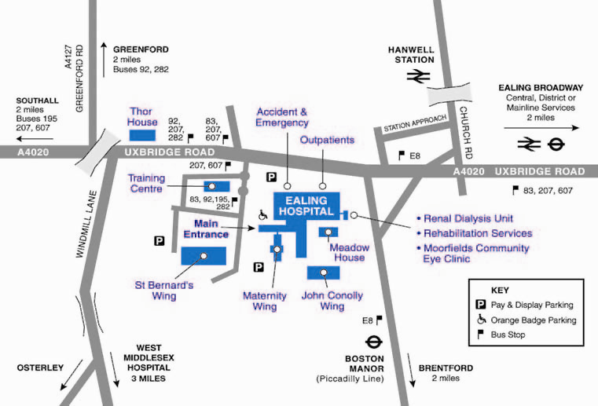

Club Welfare Officer: Luke – 078 1012 0990

County Welfare Officer: Paul Thomas – 020 7266 1650

Other Contacts for Welfare issues

ECB Child Protection Team - 020 7432 1200, Email: safeguarding@ecb.co.uk

Ealing Social Services:
http://www.ealing.gov.uk/info/200017/children_and_families/169/child_protection_and_safeguarding/6

